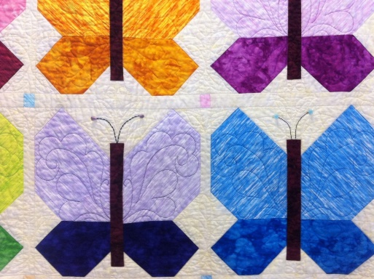
4TH ANNUAL QUILT
SHOW ENTRY FORM
MARCH 2024
CLEARMONT HISTORICAL CENTER

Entrant’s Name: ______________________________________________
Phone Number:_______________________________________________
Email Address:________________________________________________
Mailing Address:______________________________________________
Quiltmaker’s Name:___________________________________________
Quilted By:__________________________________________________
Quilt Pattern:________________________________________________
Quilt Size (Baby, Lap, Full, Etc):___________________________________
Quilt History:_________________________________________________ ________________________________________________________________________________________________________________________
Description:______________________________________________________________________________________________________________________________________________________________________________________________________________________________________

__________________________________ _____________________
Signature Date

